SIMATS ENGINEERING
ASSESSMENT TOOL 1

COURSE NAME: CSA16 COURSE CODE: Data Warehousing and Data Mining

COURSE OUTCOME COVERED

CO3: Evaluate the effectiveness of classification techniques on real-time data for accurate prediction, enabling informed decision-making. (BL3,BL4,BL5)

QUESTIONS: 5 Total Marks:50

Annexure A

Experiments

Criteria | Understanding of Concepts (2.5) | Experimental Design (3) | Use of Tools (2) | Analysis of Results (1.5) | Documentation (1) | Total(10)
Weightage | 25% | 30% | 20% | 15% | 10% | 100%
Q1
Q2
Q3
Q4
Q5

Code of Conduct:

I S ROOBINI / 192421114 (Name / Reg No) certify that this submission is my original work and that I have adhered to the guidelines specified for this assessment.
I understand that any violation of academic integrity rules will result in disciplinary action.

Signature of the student: S.Roobini

RUBRICS FOR CALCULATION:

Criteria | Weightage | Level 4 – Exemplary | Level 3 – Proficient | Level 2 – Developing | Level 1 – Beginning
Understanding of Concepts | 25 | Demonstrates thorough understanding and effectively integrates multiple concepts/technologies | Good understanding with proper integration of most concepts | Basic understanding; limited or partial integration | Poor understanding; unable to integrate concepts
Experimental Design | 30 | Well-planned, systematic implementation with optimal solution | Correct implementation with minor issues | Basic implementation with errors or inefficiencies | Incorrect or incomplete implementation
Use of Tools | 20 | Effective and advanced use of tools/technologies with proper configuration | Appropriate use of tools with correct execution | Limited or inconsistent use of tools | Incorrect or minimal use of tools
Analysis of Results | 15 | Insightful analysis with accurate interpretation and validation of results | Good analysis with reasonable interpretation | Basic analysis with limited insights | Poor or incorrect analysis of results
Documentation | 10 | Clear, well-structured documentation with diagrams, code, and results | Organized documentation with necessary details | Basic documentation with missing details | Poor or incomplete documentation

Annexure C

Experiments :

Children of three ages are asked to indicate their preference for three photographs of adults. Do the data suggest that there is a significant relationship between age and photograph preference? What is wrong with this study? (10 Marks)

Photograph:
Age of child A B C
5-6 years: 18 22 20

7-8 years: 2 28 40

9-10 years: 20 10 40

Use cov() to calculate the sample covariance between B and C.
Use another call to cov() to calculate the sample covariance matrix for the preferences.
Use cor() to calculate the sample correlation between B and C.
Use another call to cor() to calculate the sample correlation matrix for the preferences.
CODE:
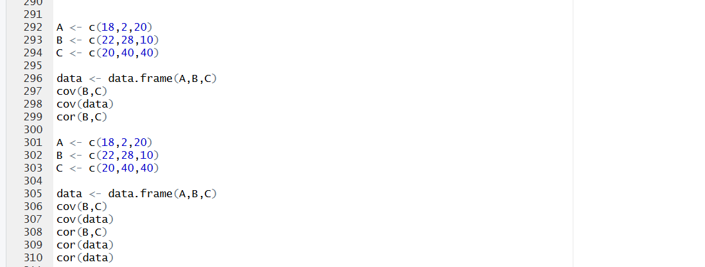

OUTPUT:
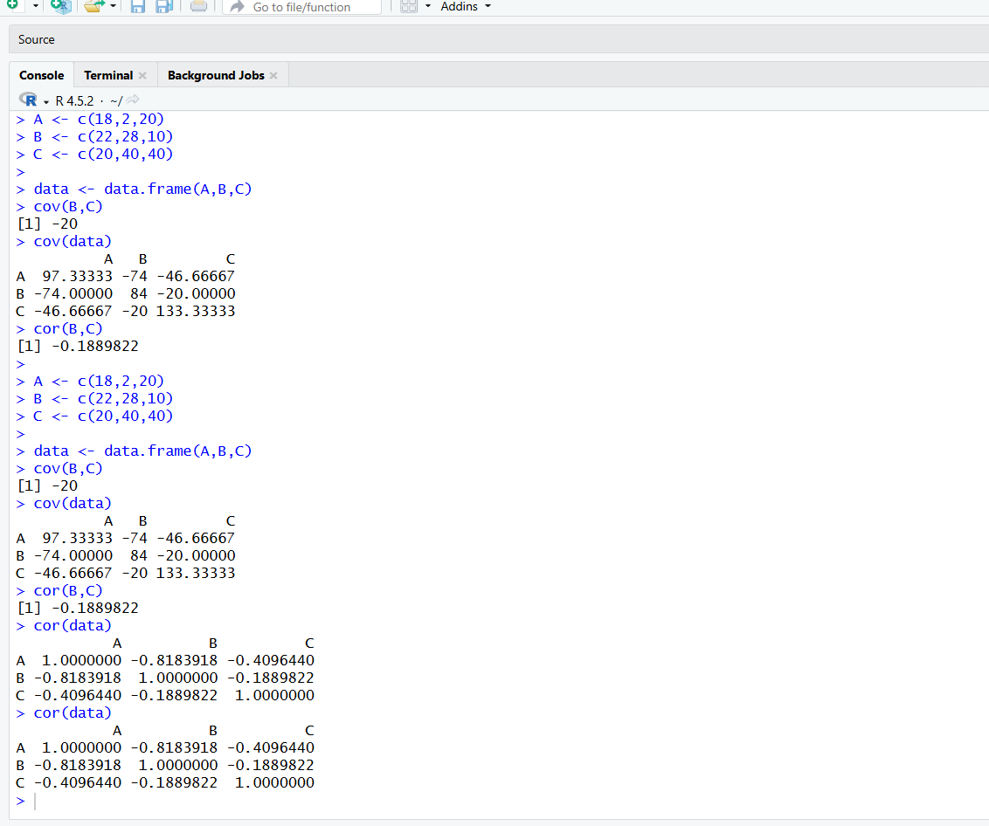

2. Assume the Tennis coach wants to determine if any of his team players are scoring outliers. To visualize the distribution of points scored by his players, then how can he decide to develop the box plot? (10 Marks)

Player ID | Player Name | Points Scored
P1 | Player A | 12
P2 | Player B | 15
P3 | Player C | 14
P4 | Player D | 10
P5 | Player E | 18
P6 | Player F | 20
P7 | Player G | 22
P8 | Player H | 13
P9 | Player I | 11
P10 | Player J | 35
P11 | Player K | 16
P12 | Player L | 17
P13 | Player M | 19
P14 | Player N | 21
P15 | Player O | 23

CODE:
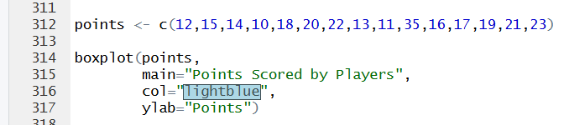

OUTPUT:
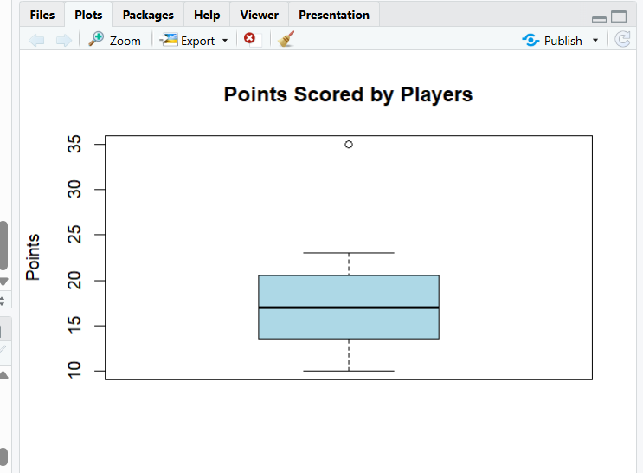
3. A bank wants to decide whether to approve a loan based on customer attributes like:
- Age
- Income
- Employment Status
- Credit Score
Using historical data, build a Decision Tree classifier to predict Loan Approval (Yes/No). (10 Marks)
Consider the Data Set
young,high,employed,good,yes
young,high,self-employed,average,yes
middle,high,employed,good,yes
old,medium,employed,good,yes
old,low,unemployed,poor,no
old,low,self-employed,average,no
middle,low,unemployed,poor,no
young,medium,employed,average,yes
young,low,unemployed,poor,no
old,medium,self-employed,good,yes
middle,medium,employed,average,yes
middle,high,self-employed,good,yes
old,medium,unemployed,poor,no
young,medium,self-employed,average,yes
middle,low,employed,poor,no

CODE:
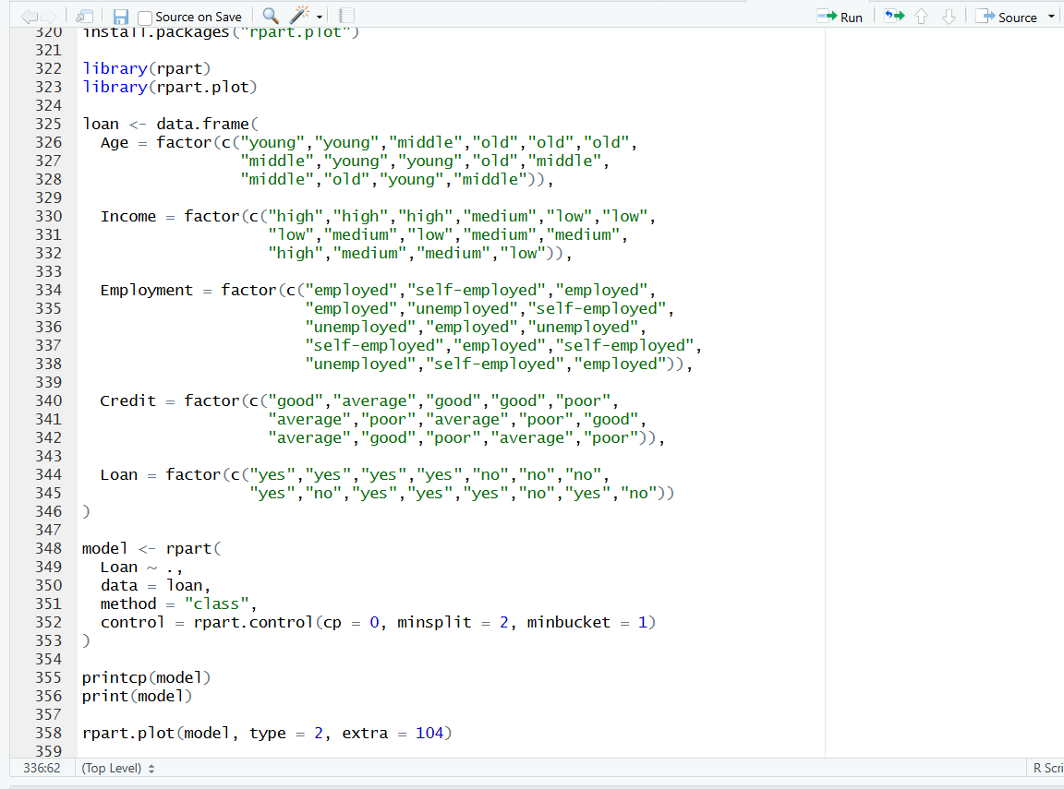

OUTPUT:

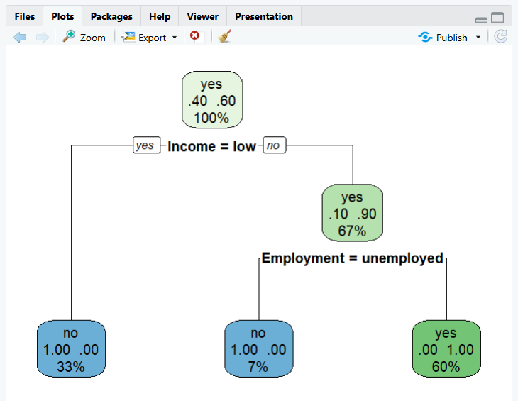

4. Two Maths teachers are comparing how their Year 9 classes performed in the end of year exams. Their results are as follows: (5 Marks)
Class A: 76, 35, 47, 64, 95, 66, 89, 36, 8476,35,47,64,95,66,89,36,84
Class B: 51, 56, 84, 60, 59, 70, 63, 66, 5051,56,84,60,59,70,63,66,50
(i) Find which class had scored higher mean, median and range.
(ii) Plot above in boxplot and give the inferences

CODE:
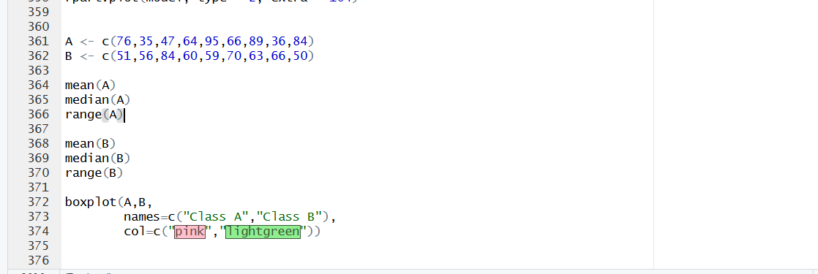

OUTPUT:
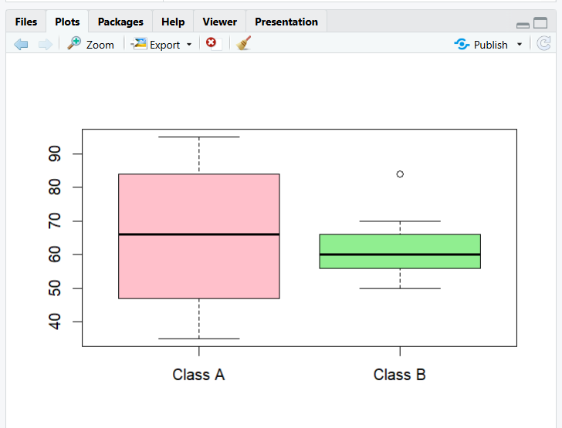

5. Suppose that a hospital tested the age and body fat data for 18 randomly selected adults with the following results: (10 Marks)

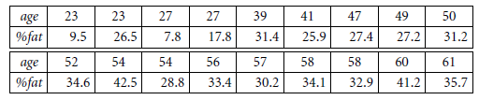
(a) Calculate the mean, median, and standard deviation of age and %fat.
(b) Draw the boxplots for age and %fat.
(c) Draw a scatter plot and a q-q plot based on these two variables.

CODE:
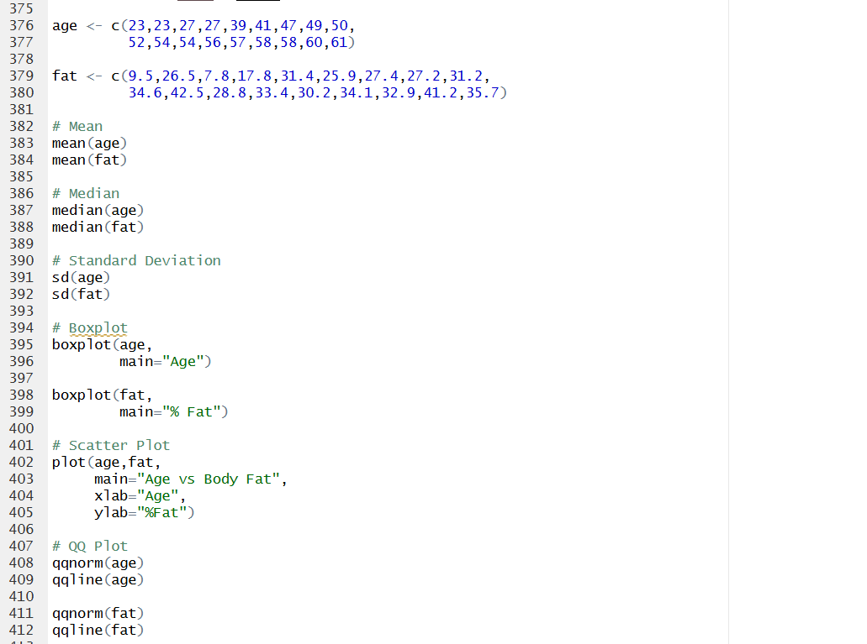

OUTPUT:
